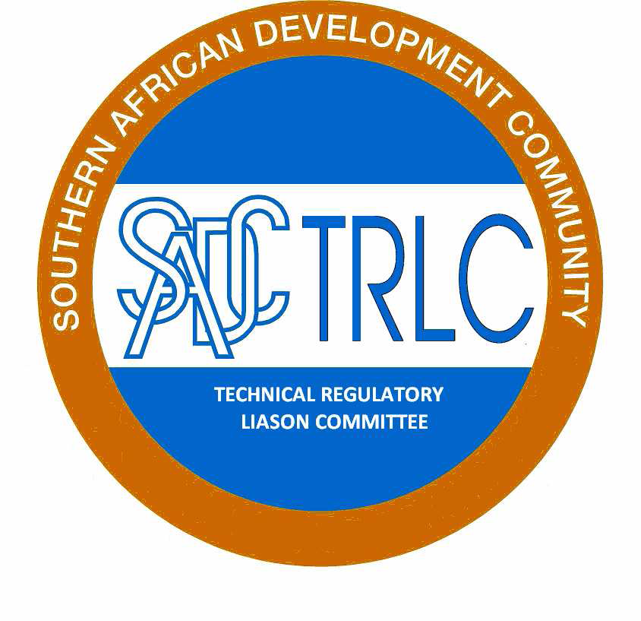



**Minute Report**

**SADCTRLC Expert WG meeting**

**Date: 4-5 February 2016**

**Venue: Gaborone, Botswana**

**ATTENDEES**

The following participants attended the expert Working Group Meeting. The participants were representative form the SADCTRLC Secretariat and SADC Secretariat.

Mr Johannes Mosanawe - (SADCTRLC Chairperson)

Mr Innocent Sbusiso Khumalo - (SADCTRLC Secretariat)

Ms Anna-Marie Lotter – (SADCTRLC Regional Coordinator)

Mr Moses Ngosa – (SADCTRLC Member)

Mr Elias Kansembe – (SADCTRLC Member)

Ms Phindile Dlamini – (SADCTRLC member)

Ms Zukiswa Raditladi – (SADCTRLC member)

Dr Oswald Chinyamakobvu – (REIS Programme SADC Secretariat)

Ms Kuena Molapo – (SADC Secretariat)

The invitation letter and attendance registers are enclosed.

**INTRODUCTION**

The meeting noted the apology from Namibia and that Ms Notemba Tjipueja is being replaced by Mr Clement Daniels. Also, that Ms Bridget Dzimwasha from Zimbabwe could not attend the meeting due to her late communication and meeting registration. The SADCTRLC Secretariat tried to assist with this regard, however the SADC Secretariat logistical arrangements were finalised and closed. The meeting encouraged members to prioritise the meeting registration and submit within the set time/s.

The meeting adopted the minutes of the previous meeting, dated the 3rd to 4th of August 2015, with minor amendments.

The meeting adopted the agenda as proposed by the SADCTRLC Secretariat.

During the time of the apologies, matters related to meeting attendance and non-responses to e-mails from Member States (MSs) came up and were subsequently discussed. There were two factors considered in this regard. These factors are language related issues and change in offices of SADCTRLC participants in their respective capitals. The latter gained precedence in terms of the discussion and the meeting confirmed the need for an alternate member for the purposes of retaining continuity as per Resolution 9 of 2015. The meeting agreed to take the issue of the language related matters to be one of the agenda items for the upcoming SADCTRLC Annual General Meeting (AGM). The meeting agreed that the SADCTRLC Regional Coordinator will draft a letter and forward this to the SADC Secretariat for signature by the TIFI Director of the SADC Secretariat, to the Permanent Secretaries in Member States. The letter will raise concerns of non-compliance with TBT Annex to the SADC Protocol on Trade and hence resolve the issues of non-responses to e-mails and meeting attendance.

**MEETING DISCUSSION AND RESOLUTIONS THEREOF**

The meeting discussed various matters as per the attached revised agenda. The discussions and conclusions were as follows:

The Regional Coordinator (RC) reported the progress report for the Risk and Impact Assessment project. The progress report is such that there are two scheduled trainings for the 22nd to 24th of February 2016 and 2nd and 4th of March 2016. All MSs, except Mauritius, (who received national EU funded training), were invited however there are nine MSs that applied with a total number of 32 participants. The meeting noted the challenges experienced regarding the confirmation of the accuracy of the translated RIA Guidelines by the MSs that are speaking French and Portuguese. The meeting agreed to finalize the common presentation on RIA after the two indicated RIA training sessions. The SADCTRLC secretariat will assist in this regard.

Also, that SADC secretariat will guide SADCTRLC in terms of RIA couching/training for funding. This will only cater for countries that did not participate in the training indicated above.

The meeting flagged that the RIA training is the train-the-trainer training, thus MSs are encouraged to ensure that the trainees trains other in their own respective MSs. The means of verification is that this item will be reported half yearly in the country report by MSs.

SADCTRLC Website: The SADCTRLC Secretariat reported that the SADCTRLC website is functional and MSs are encouraged to use the website from now on. Also, that there will be minor changes however will not impact the functioning of the website. The meeting agreed that the EXCO members shall use the website to access all SADCTRLC documents through Sharepoint. The SADCTRLC will only indicate, via the email, that there is new important SADCTRLC information. The MSs will be informed about this development in the upcoming SADCTRLC AGM. The meeting was reminded that SADC Secretariat is an ex-officio member of the SADCTRLC (in terms of the SADCTBT Annex) , thus it is important that the SADC Secretariat is accorded the log-ins to access the SADCTRLC information and documentation.

Used Motor Vehicles in the SADC Region: SADCTRLC member, Moses Ngosa, reported back on behalf of the three MSs that form part of the Sub Committee for the used motor vehicle project. The three member states are: Botswana, Swaziland, and Zambia. The presentation indicated that only Zambia have compulsory requirement in the standards for a Used Motor Vehicle. Also, that work of harmonizing used motor vehicle is under way at COMESA-EAC-SADC level. SADC secretariat is not aware of this development however commit to find and report back to the SADCTRLC. The meeting concluded that Zambia circulate the draft document for this item for inputs to all MSs, including SADCSTAN. The minute are attached in this regard with times for next activities pertaining to the used motor vehicles in the SADC Region.

The SADC Secretariat will consult in as far as the harmonized standard for the use motor vehicles in the Region.

Baseline Study on Technical Regulations: The SADCTRLC Secretariat reported in this regard and indicated that the study is finalized and requires that it is validated by MSs. The validation date is set to take two months. The work of the Baseline Study on Technical Regulations will be reported to the upcoming SADCTRLC AGM with validation disclaimer. The SADCTRLC shall assist to start with this regard as early as mid-February 2016.

The base line study proposes 24 Technical Regulations for harmonization. The meeting agreed to harmonise five (5) Technical Regulations through Swedac project and consider information from UNCTAD information. SADCTRLC Secretariat will assist to lead this process. The first meeting for this work is scheduled to take place on the 20th to 21st April 2016. Swedac will be informed about this development. The SADCTRLC EWG agreed to actively participatein this project.

The meeting considered that there will be a need to buy standards for this work and SADC Secretariat will assist in this regard. Thus, SADC secretariat will be able to buy standard under the EUREIS programme under the item called documents.

The meeting agreed to analyse the following Technical Regulations with a view on harmonisation:

1. Botswana: Standard Import Inspection Regulation.
2. Botswana: Pre-packaged labeling regulations.
3. Mauritius: Consumer Protection (Control of Imports) Regulations 1999, GN No. 135 of 1999, Electric Cable insulated with plastic materials, Armoured Electric Cables, Residual current operated circuit-breakers for household and similar uses, MS 17, MS 101 and MS 113. (South Africa will take the lead on this and will those one Technical Regulation within this range).
4. Swaziland: Biosafety Regulation 2013 Agriculture.
5. Zambia: ZS 371 Regulations (all foreign trucks required to comply with it).

Alert System: The SADCTRLC Secretariat provided the progress report in terms of project with Swedac. The report indicates that Swedac was not too keen to assist with the project since the Technical Regulations in the SADC region are not yet harmonised. The rationale is such that it will be difficult to implement in the absence of harmonised Technical Regulations.

The SADCTRLC secretariat tabled three options to continue with the project. The following summary summaries the three options:

Option One (1): That, the SADCTRLC continues with the project and use the SADCTRLC website platform. The meeting agreed that the process will be such that the SADCTRLC approach PTB to expand the scope of the SADCTRLC website via the NMISA assistance. The website will incorporate the interactive page that will allow MSs to communicate non-compliant products in the SADC region. The project or ToR proposal shall be ready during the upcoming SADCTRLC AGM.

Option Two (2): That, the SADCTRLC develops a new website strictly dealing with the non-compliant products in the SADC Region. This option did not gain positive support from the meeting.

Option Three (3): That, the SADCTRLC uses the Non-Tariff Barrier (NTB) Notification Focal Point. The meeting discussed the option at length and noted that there are challenges with it arising from the fact it is organized at the COMESA-EAC-SADC level. The SADCTRLC will further consult on this approach.

The meeting agreed that option one is practical and will give SADCTRLC more control on the proposed project and the associated work.

Lastly the meeting visited the resolution 2015/16 and rules of procedures. The meeting agreed that the entire office of the SADCTRLC Exco is up for election and thus MSs are requested to secure permission from their respective principals to contest the SADCTRLC elections. The rules of procedures we considered for revision and proposed revised draft is enclosed in this regard. Also, that it is important to kick-start the work of the five (5) year strategic plan. The meeting assigned SADCTRLC Regional Coordinator to draft the draft plan and circulate it to the member states.

**ACTION PLAN**

| **No** | **ACTIVITY** | **RESPOSIBLE PERSON** | **DATE** | **STATUS** |
| --- | --- | --- | --- | --- |
| 1 | Write a letter to Permanent Secretaries to enhance the cooperation and participation of the MSs to the SADCTRLC activities. | SADTRLC Regional Coordinator and SADC Secretariat | 9 February 2016 – submission to SADC Secretariat | Outstanding |
| 2 | Compile Common RIA presentation. | SADCTRLC Secretariat | 14 March 2016 | Outstanding |
| 3 | RIA couching/training funding for countries that are not participating in the upcoming RIA training – SADC Secretariat to give guidance in this regard. | SADC Secretariat | 14 March 2016 | Outstanding |
| 4 | Forward all documentation for the AGM to SADCTRLC members. | SADCTRLC Secretariat | 16 February 2016 | Outstanding |
| 5 | Arrange SADCTRLC Log-ins for the SADC secretariat. | SADCTRLC Secretariat | 14 March 2016 | Outstanding |
| 6 | Submission of the Draft Concept Note on the imported used Vehicle Project to SADC TRLC Exco | Zambia /SADC TLC Expert Working Group | 4th February, 2016 | Outstanding |
| 7 | Circulation of the Draft Concept Note on the imported used Vehicle Project to Member States for consultations | SADC TRLC Exco | 8th to 24th February, 2016 | Outstanding |
| 8 | Consolidation of Comments on the Concept Note of imported used Hand Vehicle Project from Member States | Zambia /SADC TRLC Expert Working Group | 3rd to 4th March, 2016 (South Africa) | Outstanding |
| 9 | Submission of Concept Note of Imported used Vehicle Project to SADCSTAN for harmonization of the Standard on Road Vehicles- Inspection and Testing for used motor vehicles for road worthiness | SADC TRLC Exco | 13th March, 2016 | Outstanding |
| 10 | Circulate the baseline study on Technical Regulation to MSs for validation | SADCTRLC Secretariat | 19 February 2016 | Outstanding |
| 11 | Report the baseline study on Technical Regulation to the AGM with the validation disclaimer. | SADCTRLC Secretariat | 14 March 2016 | Outstanding |
| 12 | Circulate the SADCTRLC draft five (5) strategic plan to Exco for SADCTRLC AGM discussion. | SADCTRLC Regional Coordinator | 29 February 2016 | Outstanding |
| 13 | MSs to secure permission to stand for Exco election. | All MSs | 14 March 2016 | Outstanding |

**CLOSURE**

The meeting was adjourned on the 5th of February 2016 with a view to implement the above-mentioned action plan.

|  |  |  |
| --- | --- | --- |
| Mr I. S. Khumalo  SADCTRLC Secretariat  ……/……./2016 | Ms A. Lotter  SADCTRLC Regional Coordinator  ……/……./2016 | Mr Johannes Mosanawe SADCTRLC Chairperson  ……/……./2016 |